DCN LAB 10

FAROOQ AHMAD
17L 4407
BEE 5B
Wednesday, November 18, 2020.
nslookup
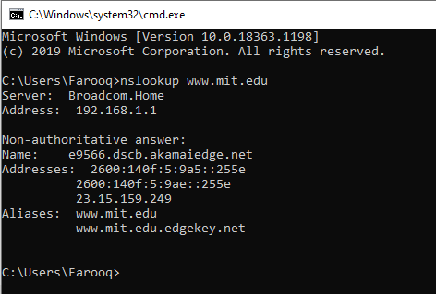

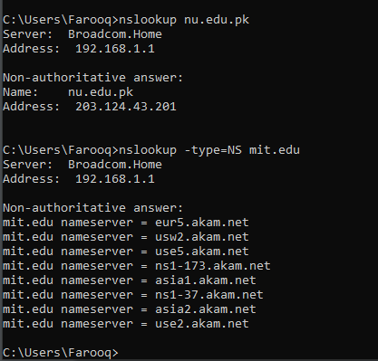
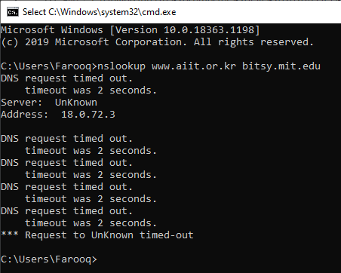

- Run nslookup to obtain the IP address of a Web server in Asia, e.g. www.lums.edu.pk. Paste screenshot of your result here:
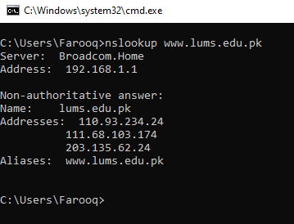

- Run nslookup to determine the authoritative DNS servers for a university in Europe (e.g., cam.ac.uk)
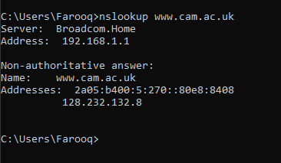
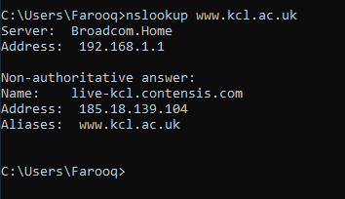
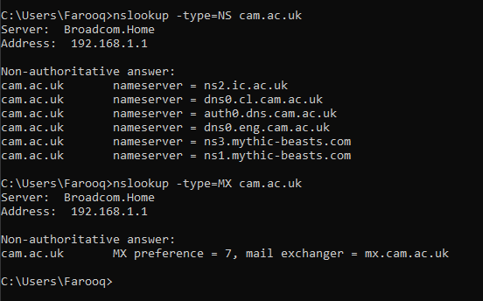
- Run nslookup so that one of the DNS servers obtained in Question 2 is queried for the mail servers for Yahoo! mail. If server does not respond, just type the command you used.
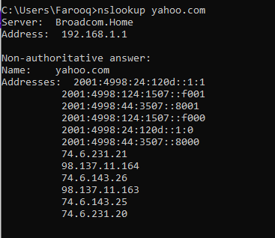
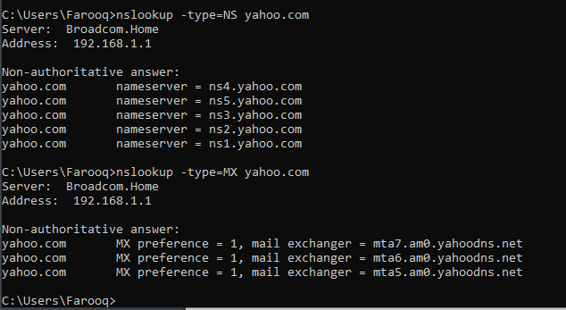
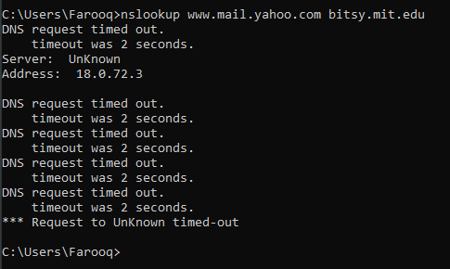

ipconfig
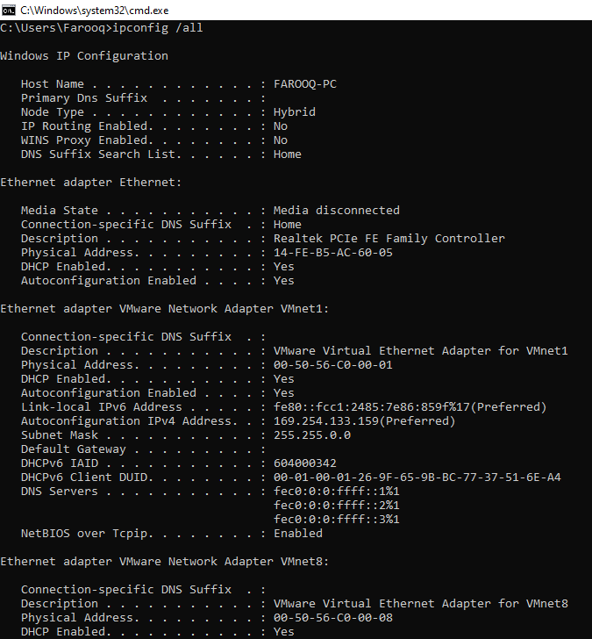

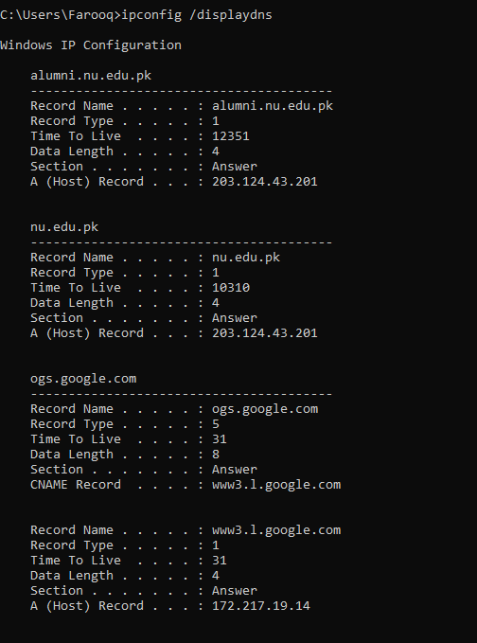
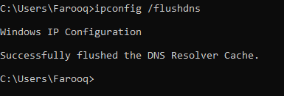

Tracing DNS with Wireshark

- Locate the DNS query and response messages. Are they sent over UDP or TCP?
UDP
- What is the destination port for the DNS query message? What is the source port of DNS response message?
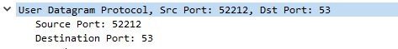
- To what IP address is the DNS query message sent? Use ipconfig to determine the IP address of your local DNS server. Are these two IP addresses the same?

- Examine the DNS query message. What “Type” of DNS query is it? Does the query message contain any “answers”?
Type A
no answers
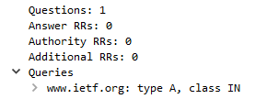
- Examine the DNS response message. How many “answers” are provided? What does each of these answers contain?
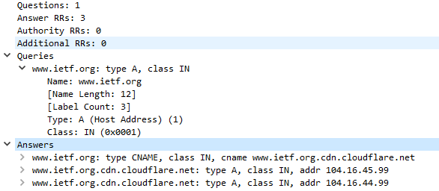

- Consider the subsequent TCP SYN packet sent by your host. Does the destination IP address of the SYN packet correspond to any of the IP addresses provided in the DNS response message?
Yes!

- This web page contains images. Before retrieving each image, does your host issue new DNS queries?
No!

Using a trace file

- What is the destination port for the DNS query message? What is the source port of DNS response message?
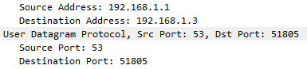

- To what IP address is the DNS query message sent? Is this the IP address of your default local DNS server?
Internet Protocol Version 4, Src: 192.168.1.3, Dst: 192.168.1.1
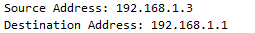
YES! This is the IP address of my default local DNS server.
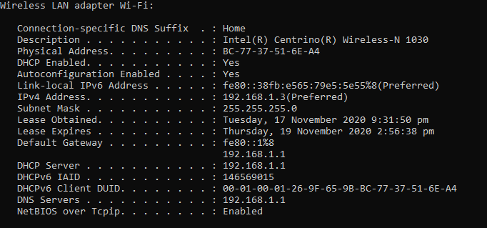

- Examine the DNS query message. What “Type” of DNS query is it? Does the query message contain any “answers”?

Type: A (Host Address) (1)
Answer RRs: 0

- Examine the DNS response message. How many “answers” are provided? What does each of these answers contain?
- Provide a screenshot.

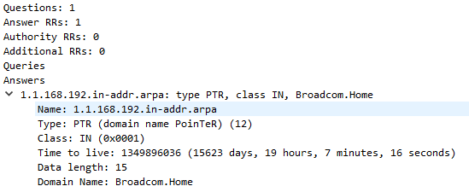

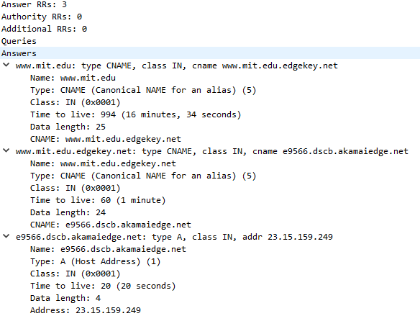

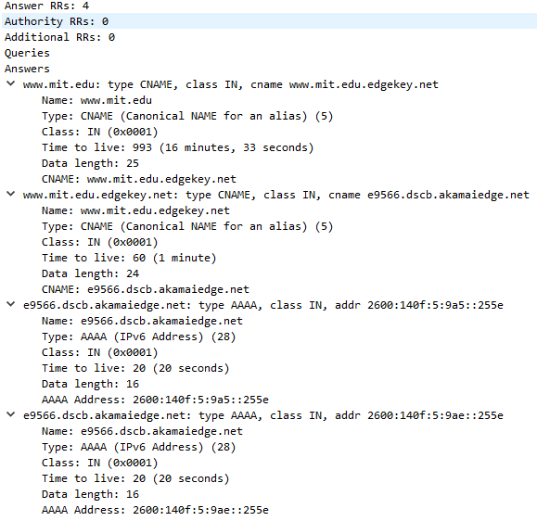

Now repeat the previous experiment, but instead issue the command:
nslookup –type=NS mit.edu

- To what IP address is the DNS query message sent? Is this the IP address of your default local DNS server?
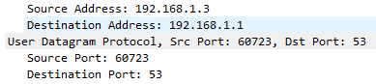
YES! This is the IP address of my default local DNS server.
- Examine the DNS query message. What “Type” of DNS query is it? Does the query message contain any “answers”?
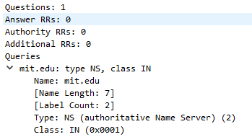
Type: NS (authoritative Name Server) (2)
Answer RRs: 0

- Examine the DNS response message. What MIT name servers does the response message provide? Does this response message also provide the IP addresses of the MIT name servers?
(authoritative Name Server) (2)
No!

- Provide a screenshot.
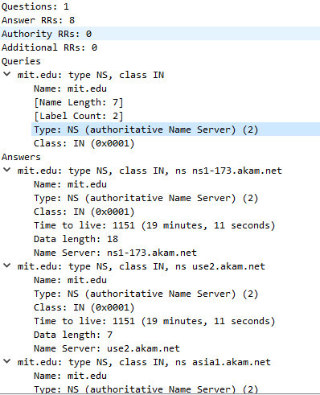

Now repeat the previous experiment, but instead issue the command:
nslookup www.aiit.or.kr bitsy.mit.edu

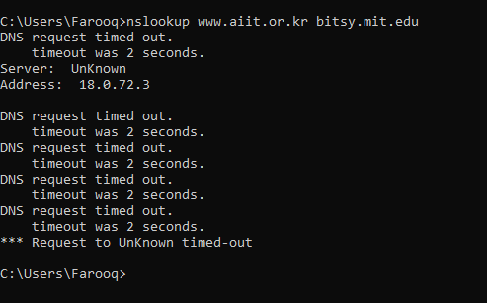
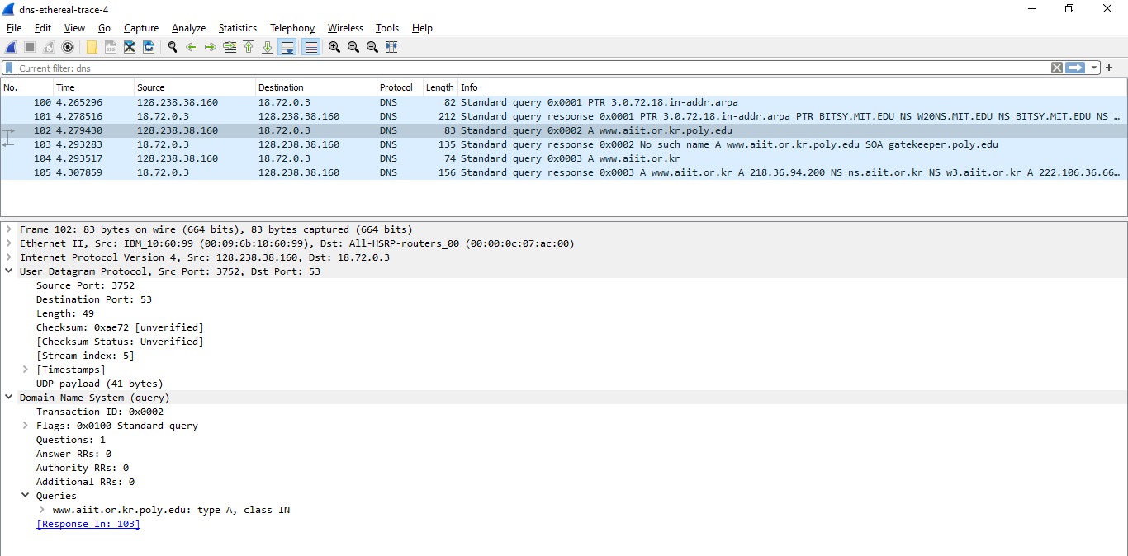

- To what IP address is the DNS query message sent? Is this the IP address of your default local DNS server? If not, what does the IP address correspond to?
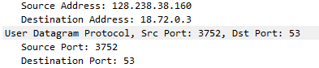
This is not the default dns server.
Destination Address: 18.72.0.3
Corresponds to bitsy.mit.edu.

- Examine the DNS query message. What “Type” of DNS query is it? Does the query message contain any “answers”?
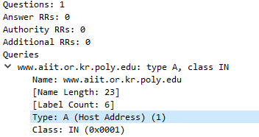
Type: A (Host Address) (1)
Answer RRs: 0

- Examine the DNS response message. How many “answers” are provided? What does each of these answers contain?
